**From:** Yeo, Wei Khoon   
**Sent:** Monday, 27 July, 2015 10:33 AM  
**To:** Chan, Pei-Fong  
**Subject:** RE: WMS Live system

Hi PeiFong,

Thanks.

But can help to add in Total # of containers and also can filter “MOT”

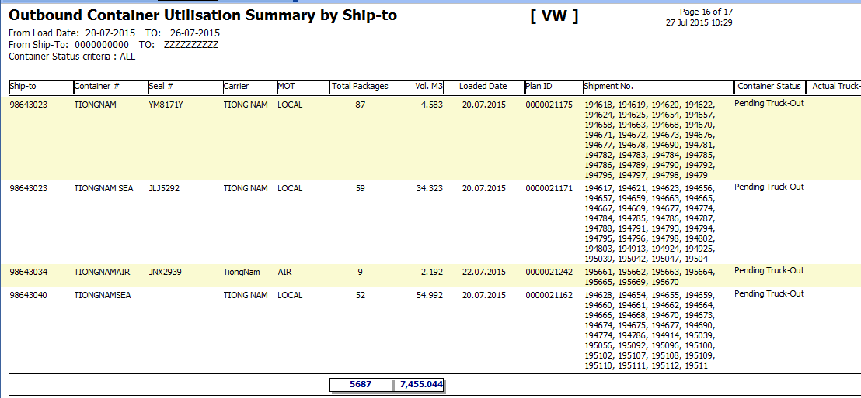

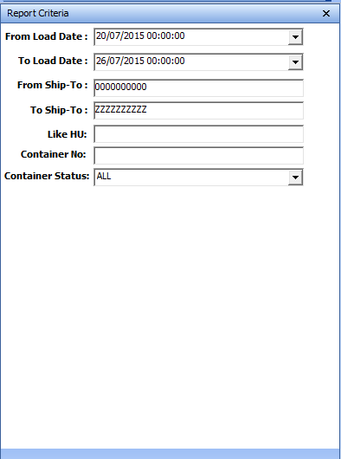

WMS CHANGES Update [2015.07.28]

1. Total container #

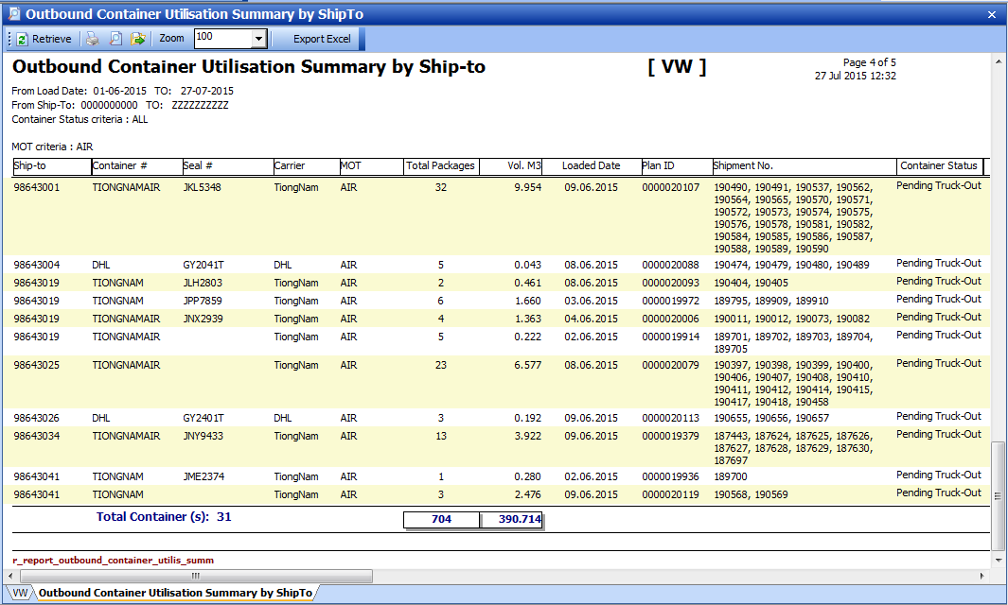

1. Retrieve criteria: MOT

